Motion Sensor Spot Light

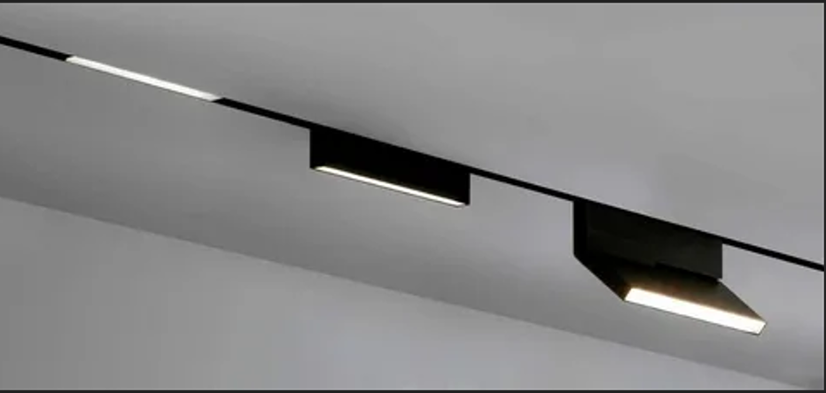

#### ****Description:****

**Motion Sensor Spot Lights** are advanced, energy-efficient lighting solutions designed to provide bright, focused light when motion is detected. These lights are perfect for enhancing security and visibility in outdoor spaces such as driveways, pathways, and gardens. With built-in motion sensors and adjustable heads, Motion Sensor Spot Lights offer both functionality and convenience.

* **Technology:** LED.
* **Compatibility:** Standard E26/E27 base (fits most fixtures).
* **Bulb Type:** Integrated LED (non-replaceable).
* **Wattage:** 10W (equivalent to 75W incandescent), 20W (equivalent to 150W incandescent).
* **Lumens:** 800 lumens (10W), 1600 lumens (20W).
* **Color Temperature:** 2700K (warm white), 3000K (soft white), 4000K (cool white).
* **Dimmable:** Yes (select models).
* **Lifespan:** 50,000 hours.
* **Energy Efficiency:** Energy Star certified.
* **Motion Sensor Range:** Up to 30 feet (9 meters).
* **Weather Resistance:** IP65 rated (dust-tight and protected against water jets).

#### ****Key Features:****

* **Motion Detection:** Automatically turns on when motion is detected, enhancing security.
* **Energy-Efficient:** Uses up to 85% less energy than traditional incandescent bulbs.
* **Focused Lighting:** Ideal for illuminating driveways, pathways, and outdoor spaces.
* **Dimmable Options:** Available in dimmable models for adjustable brightness.
* **Long Lifespan:** Lasts up to 50,000 hours, reducing the need for frequent replacements.
* **Adjustable Heads:** Allows you to direct light precisely where it’s needed.
* **Weather-Resistant:** Designed to withstand rain, snow, and extreme temperatures.

#### ****Pricing:****

* **Single Motion Sensor Spotlight (10W):** $34.99
* **Single Motion Sensor Spotlight (20W):** $44.99
* **4-Pack (10W):** 119.99(119.99(30.00 per light)
* **4-Pack (20W):** 159.99(159.99(40.00 per light)

#### ****Where to Use:****

* **Driveways:** Enhance security and visibility for vehicles and pedestrians.
* **Pathways:** Illuminate walkways for safety and convenience.
* **Gardens:** Highlight plants and garden features while deterring intruders.
* **Outdoor Entrances:** Provide bright lighting for doors and gates.
* **Commercial Spaces:** Brighten up parking lots, warehouses, and outdoor areas.

### ****Customer Reviews:****

* ⭐⭐⭐⭐⭐ "These Motion Sensor Spot Lights are amazing! They provide bright, focused light, and the motion sensor feature is a game-changer for security." – Sarah L.
* ⭐⭐⭐⭐ "Great value for the price. The lights are bright, and the installation was super easy. Highly recommend for anyone looking to upgrade their outdoor lighting." – James T.
* ⭐⭐⭐⭐⭐ "I love how energy-efficient these spotlights are. The motion sensor works perfectly, and the adjustable heads make it easy to direct the light exactly where I need it." – Emily R.

### ****How to Order:****

1. Visit our website: [www.brightworldlighting.com](http://www.brightworldlighting.com/)
2. Select your preferred spotlight type and pack size (Single or 4-Pack).
3. Add to cart and proceed to checkout.
4. Enjoy free shipping on all orders over $100!

### ****Warranty and Support:****

* **Warranty:** 2-year limited warranty covering manufacturing defects.
* **Customer Support:** Contact us at [support@brightworldlighting.com](mailto:support@brightworldlighting.com) or call +1-800-123-4567 for assistance.

### ****Visual Representation:****

Include high-quality images of the Motion Sensor Spot Lights in different settings (e.g., driveway, pathway) to showcase their versatility and design.

### ****HTML Code for Downloadable DOC File:****

If you want to provide a downloadable Word document with this information, use the following HTML code: